**Employee Service Test Plan**

# Introduction

The Test Plan is designed to prescribe the scope, approach, resources, and all testing activities for the Employee Service API

# Scope

## In Scope

The below listed Employee Service API methods are in testing scope and the respective test cases from the suite is to be automated.

* GET Employee details
* GET All Employees details
* POST Employee details
* PUT Employee details
* DELETE Employee details

## Out of Scope

These below listed features are out of scope for the current testing exercise

* User Interfaces
* Hardware Interfaces
* Database Validation
* Communications Interfaces
* Application Security and Performance

# Test Methodology

The test scripts should be designed using an object-oriented framework test framework and should be executed in the below mentioned environments

* DEV
* TEST
* PRE-PROD

# Acceptance Criteria

* Run rate is mandatory to be at 100% unless a clear reason is given
* The API responses should be validated for completeness and correctness
* Pass rate should be at 90%, achieving this is mandatory
* There should not be any open high priority or high severity defects at the conclusion of the test cycle

# Test Deliverables

* Test plan document
* Test Design specifications
* Test scripts
* Execution logs and error logs (if any)

# Testing Tools

* POST MAN (Open Source) for test design and execution
* JAVA Script/Python IDE
* Defect Management Tool

# Test Approach

In Scope API methods test scripts/flow to be designed using any of the objected oriented automation framework.

The test execution should be carried out using POST MAN by following the below procedure

* Test scripts need to be imported to the tool
* Environment needs to be configured using the Manage Environment option on the tool

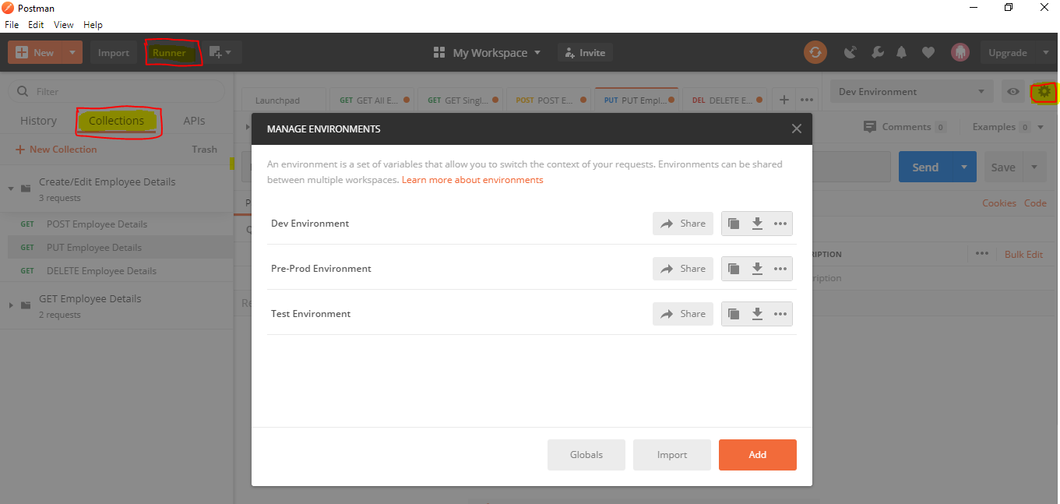

* Test needs to be scheduled using the Collection Option
* Tests are executed using the Runner option
* Test Results can be viewed/downloaded from the Run console
* Tests can also be Run and Viewed by installing NEWMAN the command line Collection Runner for POSTMAN

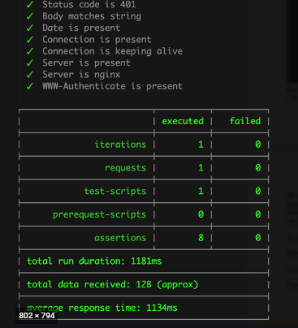

# Dependencies/Assumptions

* API is functionally stable
* Any delay in environment availability will cause timelines to be shifted
* Second round of testing will be planned based on the outcome of the initial test run and any related defects encountered during the run
* Tools setup would be completed before the commencement of testing